©NeuroSpine March 2020, 1st Edition


Lumbar Decompression and Microdiscectomy

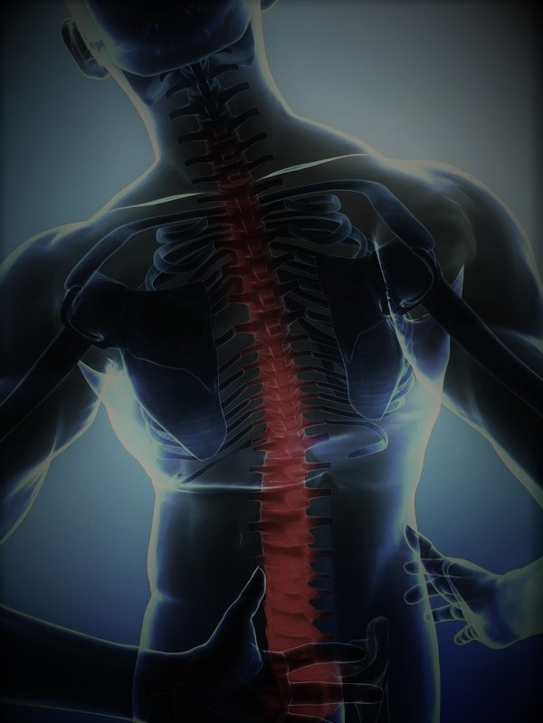

PATIENT INFORMATION BOOKLET

We hope this booklet has provided you with helpful information for your recovery following spinal surgery.
©NeuroSpine March 2020, 1st Edition

WHAT IS LUMBAR DECOMPRESSION / DISCECTOMY SURGERY?

Lumbar decompression surgery is a type of surgery used to treat compressed nerves in the lower (lumbar) spine.
Very few people who have a lumbar disc prolapse need surgery. Six out of 10 patients can get better spontaneously after six weeks, while 7 – 8 out of 10 patients will feel better by three months ^{(1).} In general, most people with leg symptoms will get better over time but Surgery seems to get people better quicker. ⁽²⁾ ⁽⁵⁾

In rare cases the nerves which control your bladder, bowel and sexual function can be compressed. This is known as cauda equina syndrome (CES) and often requires urgent surgical intervention

Lumbar decompression surgery is recommended when non-surgical treatments have not helped. The surgery aims to improve leg symptoms such as persistent pain and numbness caused by pressure on the nerves in your spine ^{(1).} It may also improve your walking and your back pain. Following your recent MRI scan and consultation with your spine surgeon, you have been diagnosed as having a lumbar disc protrusion or spinal stenosis which is resulting in nerve root compression causing your leg pain (sciatica).
Lumbar decompression surgery is often used to treat:
- spinal stenosis – narrowing of a section of the spinal canal, which puts pressure on the nerves
- a slipped disc – a damaged spinal disc herniates and presses down on an underlying nerve
Types of surgery used are
- Focal lumbar decompression – where a portion of thickened ligament (flavum) and overgrown facet joint is paired back to relieve pressure on the affected nerve
- discectomy – where the piece of herniated disc is removed to relieve pressure on a nerve
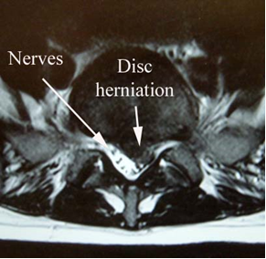
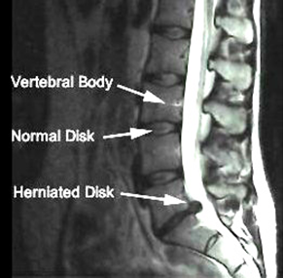
- spinal fusion – where 2 or more vertebrae are joined together with instrumentation to stabilise (fuse) and strengthen the spine

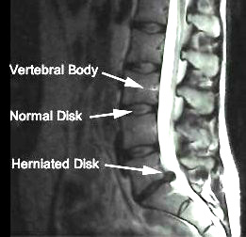

WHAT ARE THE RISKS ASSOCIATED WITH SPINAL SURGURY

It important to take responsibility as a patient to reduce the risks whenever possible. Simple measures such as stopping smoking, losing weight and improving aerobic fitness all help.

You must inform your surgeon if you are taking any of the following
- Blood thinners - Warfarin, Aspirin, Clopidogrel, Xarelto, Plavix.
- Contraceptive pill
- HRT

General Risks
There are risks involved in having any form of surgery, especially those requiring a general anesthetic include a DVT or clot, stroke, heart attack or other medical or anaesthetic problems; extremely rarely, death; as a result of damage to major blood vessels or vital organs at the front of the spine, which is 1 out of 10,000 risk. Urinary hesitancy following general anaesthesia requiring catheterisation or constipation secondary to analgesia can occur.

Risks of Spinal Surgery
- Bleeding: 1%.
- Wound infection: 1%. (may require further operations and wound washout)
- Nerve damage: 1%, it can result in pain, weakness or numbness in the leg.
- Dural tear or CSF leak: results in leakage of spinal fluid. It can occur in 2.5% - 5% of patients. If there has been a previous spinal operation it is more common because of scarring. Usually any leak is dealt with at the time of the original surgery followed by a period of flat bed rest for 1-2 days.
- Recurrent disc herniation 5%

Rarely
- Cauda equina nerve damage - resulting in bladder/bowel dysfunction or sexual function impairment
- Major abdominal vessel injury.

POST OPERATIVE ADVISE

The following instructions are general and may be changed by your Consultant depending on your surgery Research shows that the earlier you return to normal activity the better you will be ^{(3).} Activity will not do you any harm – quite the opposite ^{(4).} Even though some activities may be uncomfortable at first, your body must be kept active to promote healing A common-sense approach prevails, be guided by your symptoms.

It is normal to feel a little tired and experience stiffness and discomfort in your lower back for some time after your surgery. It is not unusual for some of the same symptoms you experienced before surgery (numbness, weakness, pain) to continue. It sometimes takes a while for your nerves to recover, and in most cases these continuing symptoms will gradually resolve as you recover from your surgery Most people recover from surgery without any problems unfortunately there is a small percentage will continue to experience residual symptoms. If you get worse than pre op, or if you become unwell, you should contact the ward.

Contact the ward emergency number or your Consultant if

- Your wound becomes red, hot, swollen or tender
- Your wound is weeping fluid
- Suddenly feeling feverish and unwell
- Loss of bladder or bowel control
- Severe headache
- New onset lower limb weakness

Wound management

The skin incision is usually closed with Steri-Strips (paper stitches and these should stay in place for 2 weeks. Your surgical wound will be covered with a sterile dressing in theatre. This should be left in place and undisturbed following surgery. If the dressing becomes wet, soiled or loose it may need to be changed. It should be inspected for signs of infection.

After 2 weeks, the Steri-Strips can be gently removed by a relative or friend or you can attend your GP or Practice Nurse if you prefer; this is best done after you remove the waterproof dressing and shower. Once the Steri-Strips have been removed the scar can be left exposed.

Wound healing goes through several stages. You may experience tingling, numbness or some itching around the wound. The scar may feel a little lumpy as the new tissue forms and it may also feel tight. These are all usual features of the healing process.

Sitting: | It is advised to limit your sitting for the first 2 weeks post-surgery. Only sit for short periods approx. 30 mins at a time. Regular movement is recommended i.e. every 30-45 minutes alternating between lying, sitting and standing.
Driving | 0-2 weeks: no driving but you can be a passenger in a car.  2-6 weeks: drive for only short journeys.  Ensure you can control your vehicle safely including executing an emergency stop. If you have a neurological deficit you are required to notify your insurance company.
Walking | Start with 5 -10 minutes walks 2-3 times a day if you can- keep moving as much as is comfortable, pace your activities.
Swimming: | Not until after your post-operative consultation.
lIFTING | No heavy lifting for first 4 -6 weeks. Do not exceed a maximum weight of 5kg. Carry items close to your body. You should avoid housework that involves repetitive twisting e.g. sweeping floor/hoovering.
Return to work | Office: 2-4 weeks. Sit for short periods, stand and walk around from time to time  Physical: After 6 weeks – Check with your surgeon
Return to sport | This will be discussed with your Consultant or Physiotherapist at your post-operative appointment.
Physiotherapy | You will be advised when to commence Physiotherapy at your post-operative appointment.

The discharging nurse can provide you with a medical certificate for the duration of your hospital stay. You will have to ask your GP for any further certificates.

The nursing and medical staff will help you to control your pain with appropriate medication. If you require any further analgesia, we advised you consult your own GP if necessary.

The ward physiotherapist will visit you after the operation to teach you exercises and help you out of bed. They will show you the correct way to move safely. Once you are confident and independently mobile, you will be encouraged to practice climbing stairs with the physiotherapist. Once stable, you will be allowed home, usually the day after surgery.

REFERENCES

- British Association of Spine Surgeons (BASS) (2018) Lumbar Disc Protrusions- Surgical Options Issue 3: March 2018 Review date: February 2021. Produced, researched and revised by spinal nurse specialist Helen Vernau on behalf of the BASS Consent and Patient Information Committee.

- A. H. McGregor, A. K. Burton, P. Sell, and G. Waddell (2007) The development of an evidence-based patient booklet for patients undergoing lumbar discectomy and un-instrumented decompression Eur Spine J. 16(3): 339–346. Published online 2006 May 11. doi: 10.1007/s00586-006-0141-9

- Ostelo RWJG, Vet HCW, Waddell G, Kerckhoffs MR, Leffers P, Tulder M. Rehabilitation following first-time lumbar disc surgery. Spine. 2003;28:209–218. doi: 10.1097/00007632-200302010-00003. [PubMed] [CrossRef] [Google Scholar]

- Ostelo RWJG, de Vet HCW, Waddell G, Kerckhoffs MR, Leffers P, van Tulder MW (2000) Rehabilitation after lumbar disc surgery. The Cochrane Database of Systematic Reviews, Issue 4. Art. No.: CD003007. DOI 10.1002/14651858.CD003007

- Wilco C Peul, Wilbert B van den Hout, Ronald Brand, Ralph T W M Thomeer, and Bart W Koes (2008) Leiden-The Hague Spine Intervention Prognostic Study Group (2008) Prolonged conservative care versus early surgery in patients with sciatica caused by lumbar disc herniation: two year results of a randomized trial. BMJ 14 June 2008.vol 336 p 1355-1358

POST OPERATIVE ADVISE

You will attend NeuroSpine for your surgical follow up approximately 6-8 weeks post operatively depending on your consultant’s instructions.

This appointment will include a review by one of our Clinical Specialist Physiotherapist and your consultant.

If you have any queries during your post-operative recovery you are encouraged to contact the ward of the hospital you attended
HOSPITAL: PHONE:
Sports surgery clinic |  | 01 5262083
Mater private
Hospital
Blackrock Clinic

Disclaimer

Whilst every effort has been made to ensure the accuracy of the information/material contained. The contents of these pages are provided as an information guide only for the reader. The reader of the information accepts full responsibility for the use he or she makes of the information. If you need any further guidance please consult a suitably qualified person.



NeuroSpine
Suite 10 The Sports Surgery Clinic Dublin 9
Phone: 01-526 2227 Fax: 01-526 2232
Email: info@neurospine.ie

©NeuroSpine March 2020, 1st Edition

